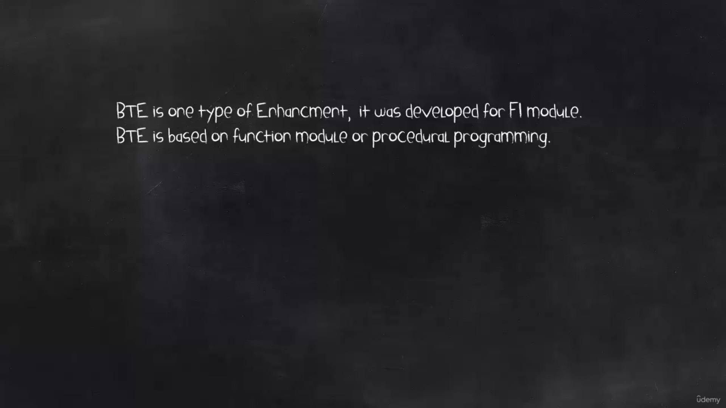

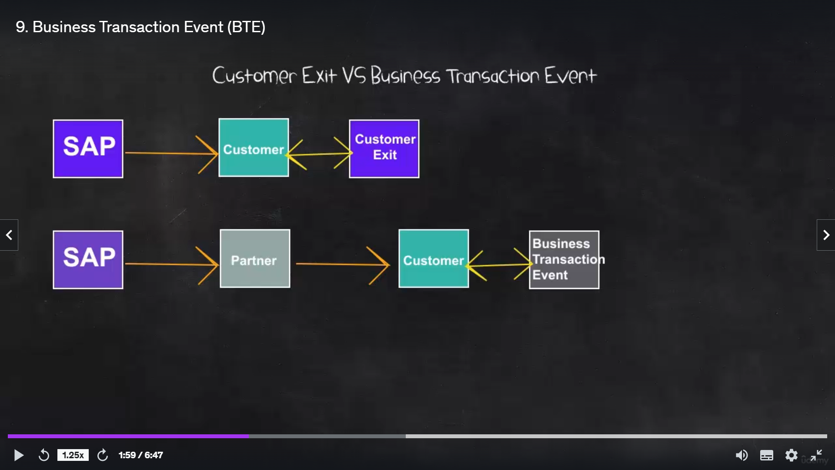

In customer exit, only two parties were involved in the delivery.

SAP produced the SAP ERP software and delivered it to its end customers, customers could enhance this standard using customer exits.

Wherever in BTE, more parties have become involved in the process SAP produced the SAP ERP software and then the next link in the chain might be a partner firm.

The last link in the chain is the customer.

So in BTE , not only as a customer that can enhance the SAP standard, but another partner firm also can do that.

But in this course only customer part is covered.

BTE uses one of the following interfaces.

* First is publish and subscribe interface.
  + with this type of interface, we can add additional process or logic to SAP standard program.
  + But the process does not influence the standard program logic. So that's why this type of interface only has importing on in.
* And then the second is process interface.
  + In contrast, to publish and subscribe interface, process interface can influence the logic of a standard program.
  + So that's why this type of interface has importing and exporting component in.

How BTE works in SAP standard program and how we as a customer can add additional logic or a process to SAP standard program using BTE?

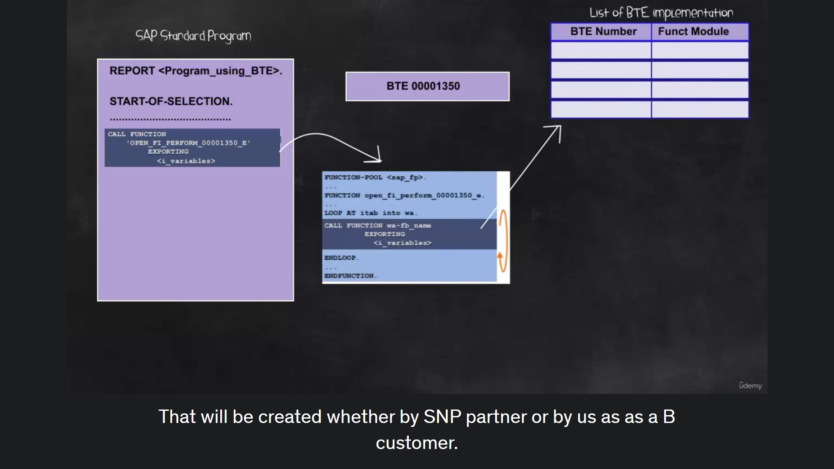

SAP developers all found some model open_FI_perform_<bte_number>_e.

This function model will search active implementation of BTE.

That will be created whether by SAP partner or by us as SAP customer and then the list of active implementations of BTE will be executed.

When the program is run in the customer site, the program will execute the standard logic and then when the customer needs to enhance this program using BTE, it is defined by SAP developers So the customer will create the implementation of the BTE by creating a function module.

The template of Functional module is provided by SAP so the customer can create the Functional module by copying the template and then registering the function module as an implementation of the BTE And then when the SAP standard program is executed again, the BTE implementation will be executed.

